Task description:

1) Create small test automation framework for http://petstore.swagger.io/ web app spec- ification (proposed combination of tools: Java/Kotlin, TestNG/Junit, REST Assured)

a) Framework should be configurable

b) Test framework should provide test reporting with tests results at the end of

tests execution.

Firstly you need some prepare your environment.

1. Please do some task from here: <https://docs.qameta.io/allure/#_installing_a_commandline>
2. Check your version: allure –version
3. Run tests with mvn clean test -Denv.HOME=https://petstore.swagger.io/v2 -Dgroups=Store/Pet
4. If all correct, you could get directory allure-results in project, then input: allure serve ./allure-results/ to the terminal.

c) Tests should use JSON format for web service interaction (not XML)

2) Test 1: Automate test case of adding a new pet to the store with verification that pet was added successfully - Test_addPets

3) Test 2: Automate test case of pet removal from the store with verification that pet was removed successfully – Test_deletePets

4) Test 3: Automate test case of placing an order to buy a pet and verification of order status (should equals “placed”) – Test_orderPets

5) Test 4: Create your own failed test so that the report will contain a failure report with the necessary information to debug further – Test_broken (just example)

6) Using tags/categories or other functionality, provide separate commands to run Test 1 and Test 2 separately from Test 3

If you are going to run Test1 and Test2 you can use:

mvn clean test -Denv.HOME=https://petstore.swagger.io/v2 -Dgroups=Pet

If you are going to run Test3 you can use:

mvn clean test -Denv.HOME=https://petstore.swagger.io/v2 -Dgroups=Store

Will be a plus (you can earn additional points):

1. Use POJO conversion to operate with REST API responses (optional advanced task which can be skipped in case time is not enough) You can see POJO classes at HomeTestAlphaSense/src/main/java/Pojo

2. We should be able to specify the application web site name during test execution via command-line assuming that ‘petstore.swagger.io’ web site name might be changed

You can use: mvn clean test -Denv.HOME=https://petstore.swagger.io/v2

3. The best way to provide the results is creating your own project in GitHub/Bitbucket and share the link: You can find here my project: <https://github.com/DidenkoAV/HomeTestAlphaSense.git>

Result home task below:

Test1 and Test2:

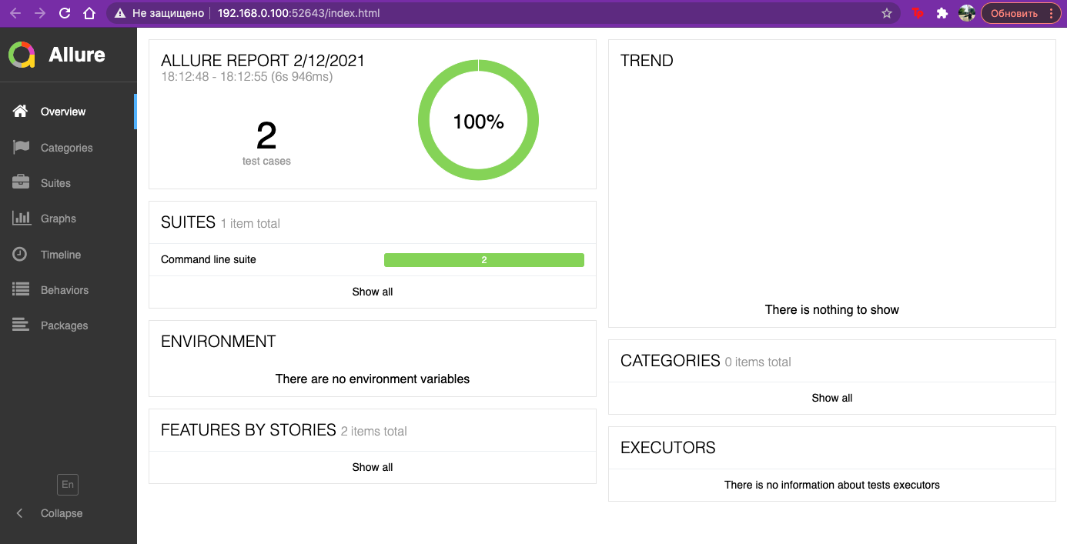

Test 3:

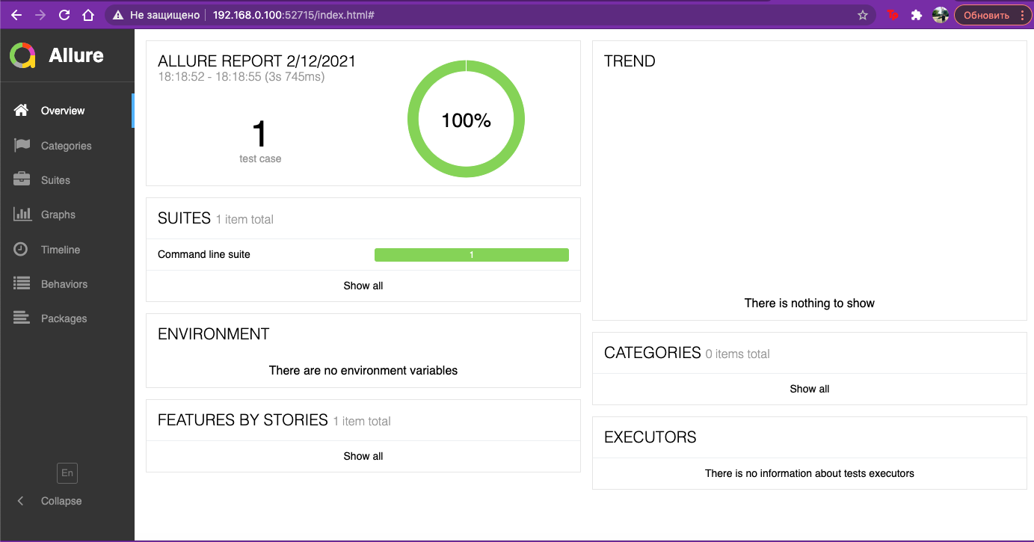

Test 4:

